Template for submission of papers to
the STI 2023 conference

First Author*, Second Author** and Third Author**

*first.author@address.com
ORCID
Department, Institution, Country

** second.author@address.com; third.author@address.com
ORCID; ORCID
Department, Institution, Country

A paper must have an abstract of 50 to 150 words.

1. Introduction
Papers submitted to the STI 2023 conference should present original research contributions. They must be submitted as a Microsoft Word document.

Research papers must have a length of at most 3000 words. The maximum length for poster contributions is 1000 words. The auxiliary sections at the end of a paper (open science practices, acknowledgments, author contributions, competing interests, and funding information) and the bibliographic references are not included in the word count.

2. Formatting
Authors are requested to use this document as a template for their paper. Before submitting your paper to the conference, please verify that the formatting has not been changed during the preparation of the paper, for instance by copying text from a document with a different formatting.

Papers should be in single column pages with a font size of 12 points (single line shifts) using Times New Roman font type.

3. Style
The style of a paper should follow the Publication Manual of the American Psychological Association (APA). In general, the background and purpose of the study should be stated first, followed by details of the data and methods used. Results, discussion and conclusions should follow in that order. The APA Publication Manual should be consulted for details as needed (https://apastyle.apa.org/).

4. Layout

4.1. Header
The first page must contain a header with the title of the paper (18 point type, Times New Roman font, centred) and the authors’ names, email addresses, ORCIDs, and affiliations (centred).

4.2. Sections
Sections should be numbered. First level section headings should be in 12-point Times New Roman, bold face with subsections in 12-point italic Times New Roman.

4.3. Tables
Tables should be incorporated in the text as close to the reference as possible. Captions should be Times New Roman 12-point, centred. Tables should be sequentially numbered. Captions for tables should be above the table.

Table 1. Table captions should be centred and placed above the table.

Table | Header | Header 2 | Header 3
Item 1 | Aaa | Bbb | Ccc
Item 2 | Ddd | Eee | Fff

4.4. Figures
Figures should be sequentially numbered and incorporated in the text by analogy to tables (see above). Figures should be in PNG or JPEG format.

Figure 1: Figure captions should be centred and placed above the figure.
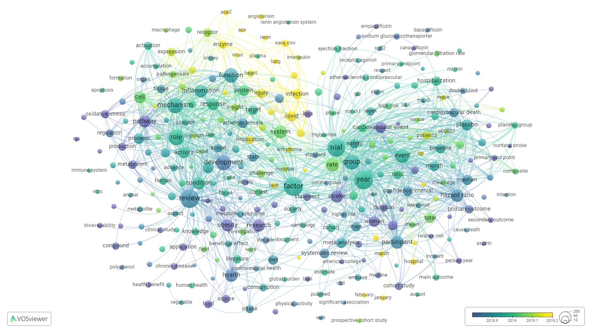

5. Bibliographic references
The format for bibliographic references follows the APA Publication Manual. Citation of an author’s work in the text should follow the author-date method of citation; the surname of the author(s), maximum three, and the year of publication should appear in text. For example, “Smith (1999) found that…”; “other researchers (Black, Duck & Tan, 2000) …”.

References in 12-point type should be listed alphabetically at the end of the paper using an unnumbered style and each single reference separated by a blank line without any indentation (see below).

Open science practices
Authors are kindly requested to include a brief section (100-200 words) at the of their paper in which they reflect on the use of open science practices in the research presented in their paper. Authors may for instance discuss the openness of the data used in their research. If the data is openly available, the authors can explain where the data can be found. If the data is not openly available, the authors can explain why they did not use openly available data or why they were not able to make their data openly available. Openness of software and source codes can be discussed in a similar way. Authors may also discuss whether a research plan was made openly available at the start of their research (‘preregistration’). Other open science practices can be discussed as well.

Acknowledgments
Authors may include a brief acknowledgments section at the end of their paper to thank individuals and organizations that have supported their research.

Author contributions
If a paper has more than one author, the authors are expected to include a short author contributions section at the end of their paper to briefly report the contributions made by each of them. Authors may use the CrediT taxonomy (https://credit.niso.org/) for this. The use of this taxonomy is optional.

Competing interests
Authors are expected to declare their competing interests in a short competing interests section at the end of their paper. Authors may also use this section to declare that they have no competing interests.

Funding information
If their research has received external funding, authors are expected to report this in a short funding information section.

References
Bauin, S. & Rothman, H. (1992). ”Impact“ of journals as proxies for citation counts. In P. Weingart, R. Sehringer & M. Winterhager (Eds.), Representations of Science and Technology (pp. 225-239). Leiden: DSWO Press.

Borgman, C.L. (Ed.). (1990). Scholarly Communication and Bibliometrics. London: Sage.

Buckland, M. & Gey, F. (1994). The relationship between recall and precision. Journal of the American Society for Information Science, 45, 12-19. https://doi.org/10.1002/(SICI)1097-4571(199401)45:1%3C12::AID-ASI2%3E3.0.CO;2-L

Hoppe, K., Ammersbach, K., Lutes-Schaab, B. & Zinssmeister, G. (1990). EXPRESS: An experimental interface for factual information retrieval. In J.-L. Vidick (Ed.), Proceedings of the 13th International Conference on Research and Development in Information Retrieval (pp. 63-81). Brussels: ACM.

